NOTICE OF RACE
2022 DII EUROPEAN CHAMPIONSHIPS

7th to 11th September 2022

Seekirchen am Wallersee, Austria

https://segelclub-seekirchen.at/

Organized by:

Segelclub Seekirchen am Wallersee

in co-operation with

Austrian Sailing Federation
Regatta Nr. 10544
Release Nr. 37228

1

RULES
1.1 | The event will be governed by the rules as defined in The Racing Rules of Sailing – Windsurfing Fleet Racing Edition (WCR).
1.2 | The Class Rules of Division II Association shall apply.
1.3 | The Championship is a Level 2 Ranking event with the coefficient of 2.
1.4 | No national prescriptions will apply.
1.5 | COVID-19 Protocols  Protocols relating to COVID-19 may be published at any time and will state if they have a status of a rule.
1.6 | If there is a conflict between the Notice of Race and the Sailing Instructions, the Sailing Instructions will take precedence. This changes RRS 63.7
2 | SAILING INSTRUCTIONS
 | The sailing instructions (SI’s) will be available upon registration. Any changes to the SI’s shall be approved by the Class Representative at the event.
3 | CLASSES & DIVISIONS
3.1 | Gender Divisions – Men and Women.
3.2 | Age Divisions: a competitor may only be entered in one age division
3.2.1 | A Youth shall be under 25 years of age (born in 1998 or later).
3.2.2 | A Master shall be aged 25 to 40 years of age (born between 1997 and 1982)
3.2.3 | A Grand Master shall be aged 41 to 55 years of age (born between 1981 and 1967)
3.2.4 | A Veteran shall be aged 56 or older (born in 1966 or earlier). Age as at 31st December 2022.
3.4 | D2EC – Sail Type divisions: A and C. Weight and age divisions may also apply.
3.5 | A minimum of 5 competitors is required to constitute a division.
4 | ELIGIBILITY AND ENTRY
4.1 A competitor shall be a paid member of the ID2CA. Membership formalities may be completed on site.
4.2 Eligible competitors may enter online - credit/debit card or bank transfer payment required. On-line entry will close on 30st August 2022.
4.2.1 An entry is not valid until paid.
4.4 The following shall be presented upon registration:
 Evidence of valid third party insurance
 Proof of age
 Parental Permission Form - for those under the age of 18
4.5 Support personnel may register onsite and the following shall be presented upon registration:
 Boat Driving Licence
 Evidence of valid third party insurance

5 FEES

5.1 Entry fee is:

Type of Entry fee | Payment made | Payment type | Entry fee
Early bird | Before 14th August 2022 | Bank Transfer | 190,00 EUR
Standard | Before 30st August 2022 | Bank Transfer | 220,00 EUR
Youth | Before 30st August 2022 | Bank Transfer | 160,00 EUR
Late Entry fee | After 31st August 2022 | Cash at registration | 240,00 EUR

5.2 Entry fees paid at registration shall be paid in cash - Euros.
5.3 Entry fees paid by bank transfer to:
Account Name: The International Windsurfing Association
Bank Details: Barclays Bank Plc, GB
IBAN: GB93 BARC 2008 4452 9772 99
SWIFTBIC: BARCGB22
Please include "D2EC" in your payment advice and e-mail confirmation of payment to: iwaoffice@internationalwindsurfing.com

6 ADVERTISING
6.1 | Boards may be required to display advertising chosen and supplied by the organizing authority.
6.2 | From the second racing day, competitors ranked first, second and third in the series at the beginning of each day shall wear on top of their clothing yellow, blue and red bibs, respectively while racing that day. The bibs will be provided by the organizing authority.
7 | FORMAT OF RACING
7.1 | The Championship shall be in the “discipline -racing”, and is “open entry”.
7.2 | A and C divison boards will have separate starts and results.
7.3 | Men and women may race together, depending on entry numbers.
7.4 | There shall be a maximum 4 races per day in a maximum 12 race series.
7.5 | Three races are required to validate the championship for each division.
7.6 | Piranja – All You Can Ride Windsurf Race will count as one race
8 | SCHEDULE
8.1 Dates and times of registration, meetings and racing

Date | Time | Description
Wednesday  7th September 2022 | 16:00 – 20:00  20:00 | Arrival & training  Registration & Equipment Inspection  Opening ceremony
Thursday  8th September 2022 | 09:00 – 10:00  11:00  12:00 | Registration & Equipment Inspection  Skippers meeting  First possible warning signal
Friday to Saturday  9th& 10th September 2022 | 09:00  10:00 | Skippers meeting  First possible warning signal

Sunday  11th September 2022 | 09:00 10:00 16:00  After Racing | Skippers Meeting  First possible warning signal  Last possible warning signal  Prize giving ceremony

8.2 | No more than four (4) races may be sailed each day.
8.3 | On the last day of racing, no warning signal, will be made after 16:00
9 | EQUIPMENT & EQUIPMENT INSPECTION
9.1 | An Equipment Inspection Form shall be completed and returned to the Event Equipment Inspectors by the close of registration.
9.2 | Equipment shall be tagged to be eligible to race – check Class Rules.
9.3 | Equipment inspections may be made at any time during the event.
9.4 | Upon completion of registration and until the end of the event, at all times when ashore except when launching and retrieving, all equipment shall be kept in their assigned places at event site. Removal of any equipment from the event site requires prior written approval from the race committee. Access to equipment in the storage area during certain hours, including hours of darkness may be restricted.
10 | VENUE
 | Addendum A shows the location of the club, regatta harbour and the racing areas. SCSW club is located in Seekirchen Bay of lake Wallersee.
11 | COURSES
11.1 | Courses will be as described in the sailing instructions.

12 | PENALTY SYSTEM
12.1 | – Sailors are allowed to pump momentarily in certain times (See attached again – Section 7)  - before and up to 1 (one) minute after start (RC to sound warning signal 1 min after start, to end pumping session)  - Downwind and reach  - Pumping not allowed going upwind
12.2 | An International Jury may be appointed in accordance with WCR Appendix N. There shall be no appeal from their decisions in accordance with WCR 70.5.
13 | SCORING
 | Scoring will be according to the WCR Appendix A.
14 | SUPPORT PERSON VESSELS
14.1. Team and support vessel drivers shall register their vessels at the Race Office before the start of the event. The registrations shall include sail numbers of boats they are supporting.
14.2. Support vessels shall be marked with numbered flags, supplied by the Organising Authority. Refundable deposit for a flag is 20,00 EUR and will be given back while returning the flag.
The number of support vessels may be limited according to regulations. Information will be provided on the event website
14.3. Coaches are encouraged to use a VHF radio. Radios will not be provided and coaches should bring their own.
14.4. It is forbidden to refuel the vessels in club area while boats are in the water
14.5. If you require a coach boat or technical support please contact info@coachboat.com.

15 SAFETY
 | Personal buoyancy is prescribed as mandatory for every competitor and support boat crewmember, who shall wear a personal flotation device that shall conform to the minimum standard of ISO 12402-5 (level 50), or as specified in the SI’s.
16 | PRIZES
16.1 | Prizes will be awarded to the first 3 competitors of a properly constituted division.
16.2 | The first man or woman in each D2EC category shall be known as the – ‘2022 Division II (category) European Champion.’
16.3 | European titles shall only be awarded to competitors eligible to compete for a European nation.
17 | OFFICIAL CEREMONIES
 | Competitors are requested to attend the event’s social functions; however, the organising authority may refuse entry to those whose standard of attire is not commensurate with the occasion. Prize winners may forfeit prizes for non attendance at the prize giving ceremony.
18 | RISK STATEMENT
 | RRS 3 states: “The responsibility for a board’s decision to participate in a race or to continue to race is hers alone.” By participating in this event each competitor agrees and acknowledges that sailing is a potentially dangerous activity with inherent risks. These risks include strong winds and rough seas, sudden changes in weather, failure of equipment, board handling errors, poor seamanship by other boards, loss of balance on an unstable platform and fatigue resulting in increased risk of injury. Inherent in the sport of sailing is the risk of permanent, catastrophic injury or death by drowning, trauma, hypothermia or other causes.
19 | INSURANCE
 | Each participating board shall be insured with valid third party liability insurance with a minimum cover of €1,500,000 per event or the equivalent.
20 | MEDIA RIGHTS
By participating in this event, a competitor automatically grants to the Organising Authority and the sponsors of the event, the right in perpetuity to make, use, and show at their discretion any motion pictures, still pictures, and live, taped or filmed television and other reproductions of him or her during the event, and of all of his or her material related to the event, without compensation.

21 FURTHER INFORMATION

For further information please contact: regatta@segelclub-seekirchen.at

Addendum A:
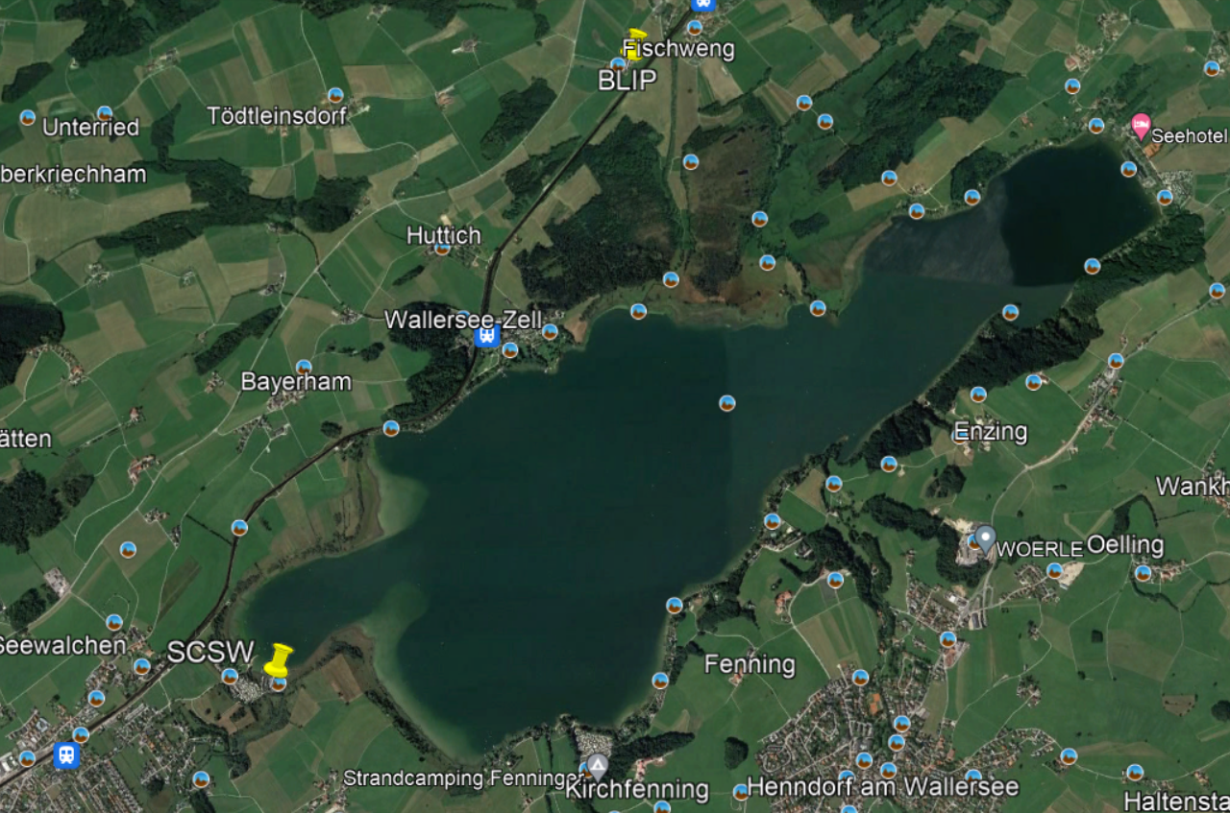
Race area

ADDITIONAL INFORMATION SHEET

The following information are not part of the rules for the Event.

INFORMATION SHET

A EARLY ARRIVALS
Competitors arriving early are advised that support from the organizers can be arranged, if confirmed in advance, from 5th September 2022.

B PREVAILING CONDITIONS
Wind: 5 - 15 knots, Water temperature: 22 - 24 degrees, Air temperature: 15 - 25 degrees

C CAMPER VANS
Further details to be published on the event website

